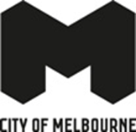

Creative Programming Framework 2025-34

Acknowledgement of Traditional Owners
The City of Melbourne respectfully acknowledges the Traditional Owners of the land we govern, the Wurundjeri Woi-wurrung and Bunurong / Boon Wurrung peoples of the Kulin Nation and pays respect to their Elders past and present. We acknowledge and honour the unbroken spiritual, cultural, and political connection they have maintained to this unique place for more than 2000 generations.
We accept the invitation in the Uluru Statement from the Heart and are committed to walking together to build a better future.

Contents
Creative Programming Framework 2025-24 1
Acknowledgement of Traditional Owners 1
Contents 1
Disclaimer 2
Foreword from the Lord Mayor of Melbourne and Councillor 2
Introduction 3
Scope 4
Principles 5
Our Creative Programming Future 6
Outcomes and measures 7
Strategic Context 8
How to contact us 10

Disclaimer
This report is provided for information and it does not purport to be complete. While care has been taken to ensure the content in the report is accurate, we cannot guarantee it is without flaw of any kind. There may be errors and omissions or it may not be wholly appropriate for your particular purposes. In addition, the publication is a snapshot in time based on historic information which is liable to change. The City of Melbourne accepts no responsibility and disclaims all liability for any error loss or other consequence which may arise from you relying on any information contained in this report.

Foreword from the Lord Mayor of Melbourne and Councillor
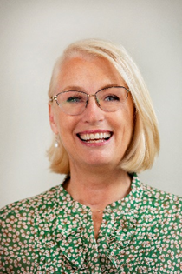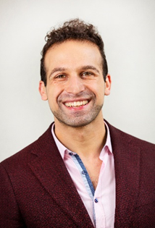
Melbourne is a city that values the arts. We are the undisputed arts capital of the nation and remain committed to nurturing our creative spirit so that we continue to evolve and grow as a hub of artistic and cultural innovation.
The Creative Programming Framework serves as a testament to this dedication to the arts – a sector that is pivotal to our city's dynamic character, communal wellbeing and vibrant economy.
This framework lays the groundwork for fostering diverse and meaningful artistic engagements. It ensures that our support extends across the entire arts ecosystem – creating a space where the arts can continue to challenge, deepen our understanding of place, self and other, while enriching Melbourne's cultural capital.
We are proud to invest more than $5 million to support more than 800 artists, facilitate more than 3,500 activities city-wide and attract some 1.5 million audience members each year.
Our programs, such as Arts House, ArtPlay, SIGNAL, and the extensive Libraries network, are designed to resonate with a broad audience, from the youngest to the eldest, championing creativity across various forms and expressions.
This framework is not just about nurturing the arts; it is a commitment to uphold Melbourne's distinct cultural identity. It is about providing the creative sector with the support it needs and ensuring equitable and inclusive opportunities for artistic expression.
As we embrace this journey, we are excited to see how these initiatives will further enrich the lives of Melbournians and visitors alike, ensuring our city remains the most exciting place to live, work and explore.
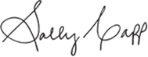
Sally Capp AO
Lord Mayor
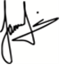
Jamal Hakim
Councillor
Creative Melbourne Portfolio Lead

Introduction
Melbourne’s creative scene is renowned for its originality, independent spirit, and commitment to pushing boundaries. Recognising our changing demographics and the importance of cultural innovation and vitality to the life of the city, our creative future is dynamic, and we are ready to adapt to the needs of artists, residents, and visitors alike.
The City of Melbourne proudly wears its reputation as a global leader in the arts. Through our venue-based programs at Arts House, ArtPlay, SIGNAL and our Libraries network, we offer dynamic and relevant creative programming, participation, and learning activities.
In our role as a capital city, Melbourne endeavours to strike a delicate balance, catering to the needs of the creative sector and communities. As audience behaviour evolves and community and artist needs change, we have developed our first Creative Programming Framework that articulates clear principles and purpose for creative programming within our arts venues and libraries.
The City of Melbourne has been a longstanding leader in arts programming, embodying a unique role as both enabler and presenter. The city sees its programming as a means to achieve community visions and aims to reflect the communities it serves, maintaining a leadership role in supporting artists and fostering creative experimentation and expression.
The development of the Creative Programming Framework is informed by extensive consultation, engaging artists, audiences, industry bodies, and stakeholders. It reflects Melbourne's commitment to inclusivity and responsiveness to its ever-growing and changing population.
The Creative Programming Framework is designed to be a decision-making tool that not only links creative programming to broader Council plans but also positions the City of Melbourne as a global leader in community-focused creative programs. This framework encompasses the program areas of Arts House, ArtPlay, SIGNAL, and Libraries, each contributing to the city's vibrant cultural tapestry.
With a commitment to supporting artists, connecting people, reducing barriers to access, and serving as a pipeline for new Australian works, the Creative Programming Framework is set to shape the city's cultural landscape for years to come.

Scope
The Creative Programming Framework encompasses the planning, execution, and assessment of artistic initiatives within Arts House, ArtPlay, SIGNAL, and Libraries. The framework emphasises equity and access, guided by a community and artist focused ethos.
The programs within this framework include:
- Arts House supports artistic development and commissions, produces, and presents experimental and contemporary performance and interdisciplinary art.
- ArtPlay develops and presents contemporary performance, installations, and participatory work by, with and for children (ages 0-13 years) and families.
- SIGNAL is a multi art form creative studio for young people 14-25 years delivering workshops, residencies, and new work commissions.
- Libraries programming relates to artists commissioned to provide creative and lifelong learning, presentation and artistic development in event spaces, and creative technology through makerspaces.
Creative programming refers to the commissioning and presentation of artists to create artworks and facilitate creative learning and participation activities. These activities are hybrid in delivery within arts venues, libraries, public space and online. They encompass visual arts exhibitions, theatre and dance performances, music gigs, talks and ideas, and workshops.
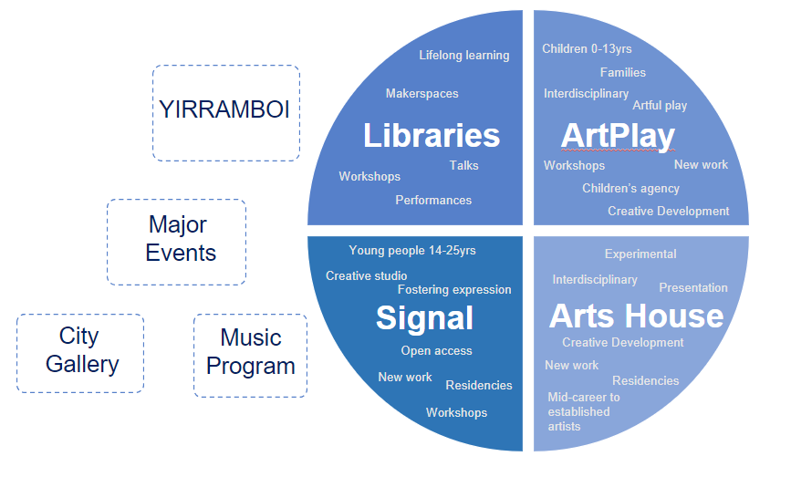
In addition to the programs represented in the Creative Programming Framework, the City of Melbourne commissions and presents creative programs via the biennial YIRRAMBOI Festival, music assets the Federation Bells and Melbourne Town Hall Organ, City Gallery, as well as through major events such as the Now or Never and Moomba festivals.

Principles
Our principles for creative programming have been developed through extensive consultation. They will guide the decisions we make around commissioning, presentation, and delivery of artist development and community creative learning and participation programs.
- Responsive to community needs:
  - Identify and engage communities and artistic cohorts to tailor programs to their needs.
  - Support self-determined ways of working, programming, and engaging with First Nations communities and artists.
  - Stay attuned to the current political, social, and cultural climate, adapting programming to address issues relevant to the municipality and engage with the community effectively.

- Wise practice in artist support and development:
  - Learning from the cultures and knowledge systems of First Peoples, implement and uphold wise practices in supporting and developing artists that consider many contexts, cultures, knowledge systems, and ways of doing.
  - Provide comprehensive resources, mentorship, and opportunities to foster the growth and sustainability of artists within the community.
  - Move beyond best practice as a singular and universal benchmark for measuring artist experience.

- Function as facilitators and presenters of creativity:
  - Recognise the dual role of the City of Melbourne’s creative programming plays in the arts ecology nationally, supporting artist growth through career stages and audience development across age groups.
  - Recognise our role as facilitators in the realisation of artistic visions through the life cycle of a work from concept to presentation
  - Present programs that not only showcase artistic talent but also contribute positively to the cultural fabric of Melbourne and Victoria.

- Equity in our DNA:
  - Embrace equity, justice, and self-determination as fundamental values in all aspects of programming, positioning Melbourne as a city where everyone has a voice, can contribute, and thrive.
  - Prioritise underrepresented voices, perspectives and lived experience to ensure a broad and inclusive representation in the creative landscape.

- Innovation and experimentation:
  - Encourage a culture of innovation, experimentation, and risk-taking in programming decisions cementing Melbourne’s reputation as a leading creative city globally.
  - Support unconventional and boundary-pushing artistic expressions that challenge traditional norms and expand the creative landscape.
  - Continue to be a world leader in the development of programming with and for young people.

Our Creative Programming Future

- Finding new people and ways to welcome them:
  - Actively seek out broader engagement with artists, audiences, and communities.
  - Explore innovative ways to make programs more accessible and appealing to a broader audience.

- Community-led programming:
  - Develop spaces and programs that empower grassroots collectives, organisations, and communities.
  - Maintain the balance between experimental and artist-led programming and open, inclusive initiatives.
  - Adapt curated programs to the evolving demographics of the community.

- Partnerships:
  - Collaborate with partners and across creative programming areas to diversify and enhance program offerings.
  - Utilise partnerships and relationships to reach new and emerging artists and audiences and expand the impact of creative programming.
  - Shift towards a curatorial model that emphasises collaboration and complements rather than competes with the creative sector.

- Advocate for creative programming as a tool for engagement and storytelling to support the achievement of Council’s goals:
  - Focus programming efforts on addressing the needs of under-serviced, marginalised communities, and untapped audiences.
  - Use creative programming to raise awareness of municipal issues fostering a deeper connection between the arts and broader societal concerns.
  - Inform creative sector policy using trends and data to respond to and advocate for the needs of artists and communities in the city.

Outcomes and measures

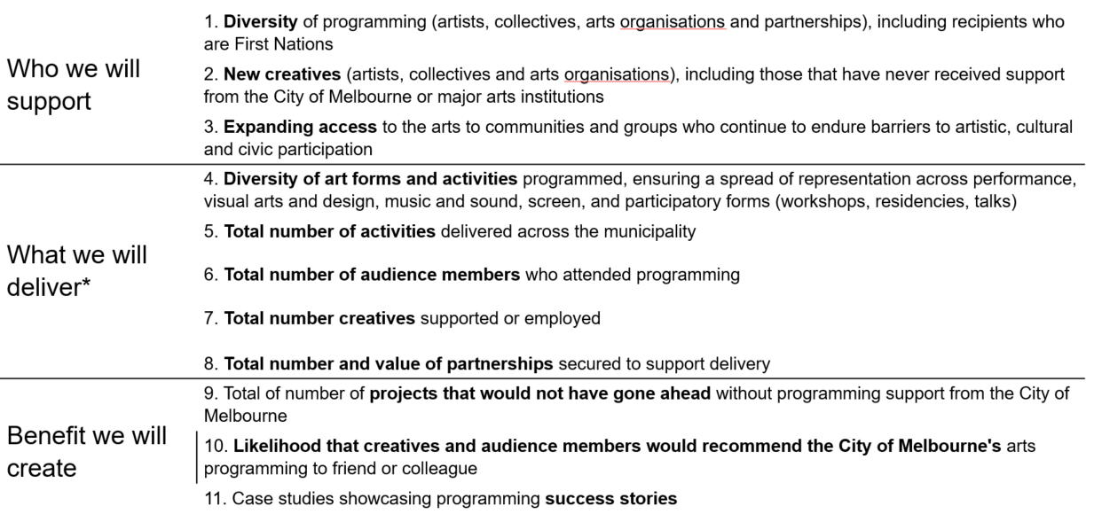

Strategic Context
The City of Melbourne provides creative individuals with spaces like Arts House, ArtPlay, SIGNAL, and Libraries to make art, develop their skills, and engage with communities. The city's unique venue-based programming is well-respected in Australia and globally. ArtPlay is known around the world as a leading creative space for children and artists and has inspired the establishment of similar spaces in Singapore and South Korea. Arts House has developed a loyal following of arts audiences seeking experimental work. It is highly sought after by independent artists and small-medium companies as a place of artistic inquiry to create bold and adventurous work.
Local governments, like the City of Melbourne, play a crucial role in supporting the creative sector and we are committed to developing new work and fostering community engagement. Our programs serve as a stable force for artists, the independent and small-to-medium arts sector, and communities and audiences seeking creative participation. This contributes significantly to Melbourne's cultural vitality.
From amplifying First Nations artists and voices and the 60,000 years of unbroken cultural practice in Naarm/Melbourne, to collaborating with the many neighbourhoods and their communities, all these programs are anchored in the places and sites where they are located. Arts House, ArtPlay, SIGNAL, and Libraries implement curated programming through open call applications and direct curatorial invitations. They prioritise uplifting voices that may not be well-known in the community, giving children and young people agency in their creative pursuits, and reaching out to under-represented communities. These programs offer career breakthroughs for artists and work in meaningful partnerships with major and grassroots organisations.
The City of Melbourne's investment in creative programming leverages partnerships and attracts support from local, national, and international entities, showcasing Melbourne's commitment to curatorially rigorous programming and consistently high audience satisfaction. Staff and guest curators often present at industry forums, and the exhibitions and shows travel to major festivals and arts centres worldwide.
Creative engagement is beneficial for people of all ages. Participating in arts and cultural activities has been linked to positive mental health outcomes, reduced stress, fostering lifelong learning and an increased sense of belonging. Our Libraries Hubs provide affordable spaces for creative practices and creative expression that are accessible to all. The City of Melbourne's commitment to reaching out to under-represented communities ensures that diverse and often marginalised people have access to these enriching experiences and positive outcomes.
For children, programs like ArtPlay not only provide a space for creative expression but also empower them to take control of their artistic journey. Allowing children to drive their own creative practice not only enhances their artistic skills but also nurtures their self-confidence and critical thinking abilities. This hands-on involvement in the arts at an early age contributes to the development of skills that can be applied throughout their entire lives.
For young people, SIGNAL offers a unique opportunity beyond formal educational pathways to access free creative workshops, learn from professional artists, and explore new or unfamiliar art forms within the heart of the city. This kind of programming gives young people a safe space where they can actively choose the direction in which they want to develop and expand their creative skills and thinking, helping to build self-confidence, artistic voice, and expression, and fostering their understanding of collaboration and creative problem-solving.
In addition, the city's emphasis on artist and community engagement, and the cultivation of new audiences for contemporary practice, with free or accessible ticket prices, makes creative participation inclusive and open to everyone. This inclusivity is vital for building a vibrant and cohesive community where people from different backgrounds come together to share and celebrate their creativity.
The Creative Programming Framework 2025–34 is informed by a number of key City of Melbourne strategy documents.
Council Plan 2021–25 outlines Council’s four-year objectives to achieve the Community Vision. Objective 1 – Economy of the Future describes the creative energy of the municipality as harnessed and enhanced, to be a defining feature of Melbourne’s unique character and contributes to its ongoing economic resilience and viability. Replacing the Reconciliation Action Plan is a new First Nations Strategy (in development) which will sit alongside the Council Plan. First Nations culture and heritage is more than reconciliation, which is why the new strategy will include initiatives celebrating Aboriginal Peoples’ unique heritage and culture within the municipality.
Creative City has always held as a key priority, to be inclusive, accessible and embrace the diversity of our communities – as outlined in Inclusive Melbourne Strategy 2022 – 2023. While the benefits of creatives to a city are well documented in both economic and non-economic terms, the Economic Development Strategy 2031 articulates the value of a creative resurgence to the city.
Creative City Strategy 2018 – 2028 takes a 10-year view on how we integrate creativity into everything we do – not as an add-on but planned from the start of a project, development, or activity. Cities that have creativity at their core are the ones that prosper and apply creative practice on a civic scale. We are also placing ‘art at the start’ to draw on the full potential of our extraordinary creative community.
Within Creative City, there are other key frameworks in addition to the Creative Programming Framework 2025-2034. These key documents are informed by the over-arching Creative City Strategy:
- Creative Funding Framework 2024 – 2030
- Public Art Framework 2021 – 2031
- Arts Infrastructure Framework 2016 – 2021 (in development)
- Future Libraries Framework 2021 – 2025

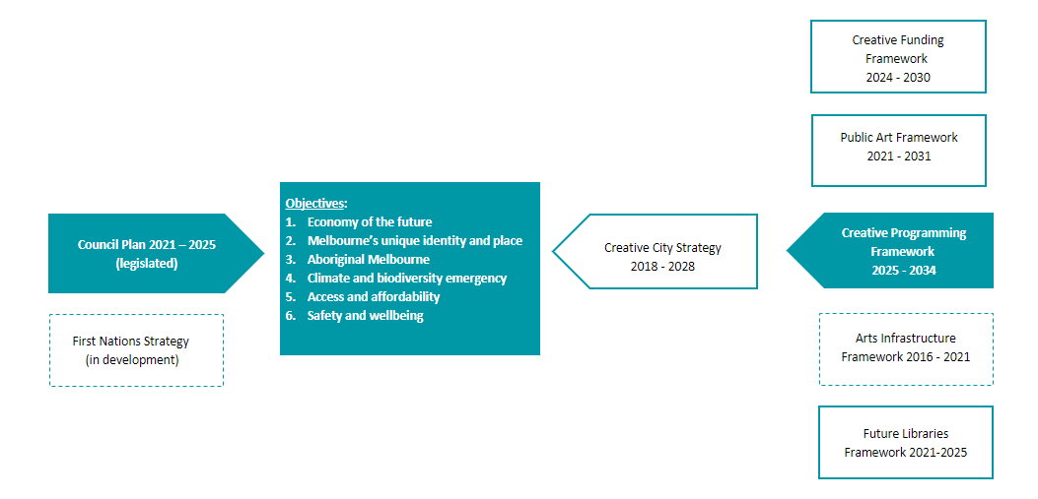

How to contact us
Online
Go to City of Melbourne website
melbourne.vic.gov.au

In person
Melbourne Town Hall – Administration Building
120 Swanston Street, Melbourne
Business hours, Monday to Friday (Public holidays excluded)

Telephone
03 9658 9658
Business hours, Monday to Friday (Public holidays excluded)

Fax
03 9654 4854
In writing
City of Melbourne
GPO Box 1603
Melbourne VIC 3001
Australia

Interpreter services
We cater for people of all backgrounds
Please call 03 9280 0726

National Relay Service
If you are deaf, hearing impaired or speech-impaired, call us via the National Relay Service: Teletypewriter (TTY) users phone 1300 555 727 then ask for 03 9658 9658 9am to 5pm, Monday to Friday (Public holidays excluded)

